Date: Primary School 4th September 2021, Saturday
Secondary School 11th September 2021, Saturday

Venue: https://woogles.io/

Number of games: 6 games + Best-of-2 Finals for Top 2 finishers (Primary)
8 games + Best-of-2 Finals for Top 2 finishers (Secondary)

 | Secondary School Category | Primary School Category
Date | 11th September 2021 (Saturday) | 4th September 2021 (Saturday)
Reg Fee (incl GST) | S$5 | S$5
Event Time | 10.30am - 6.00 pm (8 games*) | 10.45 am - 5.30 pm (6 games*)
Note: Any participant who fails to turn up ten minutes after the reporting time has lapsed shall be deemed to have given up interest in participating in the tournament.
 | *Top 2 players will proceed to a 2-round finals
Prizes are projected based on a turnout of 30 per category
Break time | Lunch from 1 pm – 2 pm | Lunch from 12.40 pm – 1.40 pm
1st Prize | Gift Voucher S$50 + Medal | Gift Voucher S$50 + Medal
2nd Prize | Gift Voucher S$40 + Medal | Gift Voucher S$40 + Medal
3rd Prize | Gift Voucher S$30 + Medal | Gift Voucher S$30 + Medal
4th Prize | Medal | Medal
5th Prize | Medal | Medal

Format
Players from either division will be randomly paired in the first round. For subsequent rounds, the King-of-the-Hill (KOTH) format will be applied, where the top player at the end of the previous round will play the second player, third plays fourth, fifth plays sixth and so on. At the end of Round 6 (Primary Division) or Round 8 (Secondary Division), the top two players in each division will proceed to play each other in a Best-of-2 final.

Finals Format
In the first round of the finals, the player with higher wins followed by higher spread will start first in the Final 1. The start will then be reversed from the Final 2. In the event of a draw in the final, the player with a higher spread will be determined as the winner.

Payment
Bank transfer
Alternatively, you can make a bank transfer to the Scrabble Association account (UOB Current Account 907 344 1648) with your name in the remarks or message to the payee. Once payment is done, please send a screenshot of proof of payment and the completed entry form(s) with the required particulars of each participating student being furnished.

All queries on payment should be directed to the Scrabble Association Youth Committee at HP: 9677-0503 / Email: youth@toucanet.com.

Rules and Regulations

WESPA Rules Version 4 shall be adopted for use in this tournament. A copy is available at https://www.wespa.org/wesparulesv4.pdf. The reference for acceptability of words is Collins Official Scrabble Words 4th edition published in 2019 ("CSW2019").

The organisers reserve the right to stop accepting registrations at any time once the quota of participants has been reached. Registration will be based on a first-come first-served basis.

Before the Tournament

To maintain the integrity of this virtual event, video monitoring will be used. All players are required to prepare two devices for the event - a laptop/desktop to access Woogles and compete, and another device (with camera) to log in to a Zoom meeting. The Zoom camera must show a clear view of the player and their workspace (i.e. face, hands, laptop/desktop screen and must remain on throughout the event.

All participants should also create a Woogles account and submit their Woogles handle in the entry form. Students can access https://woogles.io to create their account.

General Information

The Scrabble Association conducts free scrabble practice/coaching sessions every Friday from 8.30 pm to 10.00 pm on Woogles, www.woogles.io. General enquiries on the Scrabble Championship or practice/coaching sessions may be directed to youth@toucanet.com or sent to the Scrabble Association Facebook page.

~~~~~~~~~~~~~~~~~~~~~~~~~~~~~~~~~~~ ENTRY FORM ~~~~~~~~~~~~~~~~~~~~~~~~~~~~~~~~~

This entry form shall be completed in BLOCK LETTERS and returned to Scrabble Association via email at youth@toucanet.com together with your payment, not later than 30th August 2021. Entries without payment will not be accepted. Photocopied entry forms may be used.

Category D – Primary School Student (6 games, 8 for finalists) Time: 10.45 am, 4th Sep 2021

Category E – Secondary School Student (8 games, 10 for finalists) Time: 10.30 am, 11th Sep 2021

 | Name(s) of participating student(s)  (according to IC) | Woogles Handle  (compulsory) | Age | Contact No.
1
2
3
4
5
6
7
8
9
10
(Please use additional sheets if there are more than 10 participating students)

Name of School: ________________________________ Email Address: ________________________________

Name of Teacher/Applicant: ____________________________ Handphone No: _________________________

I have read the Rules and Regulations of the Virtual National Youth Scrabble Championship 2021, and hereby agree to abide by the Rules and Regulations set by the Organiser. I also agree to indemnify the Organiser for any injury sustained or loss of property during this Competition.

NOTE:
Failure to Report: Any participant who fails to turn up Ten (10) minutes after the reporting time has lapsed shall be deemed to have given up interest in participating in the tournament.

---------------------------------------------------  Signature of teacher/parent/  guardian/student (delete where applicable) | Facebook page: https://www.facebook.com/scrabbleassociationsg  Email: youth@toucanet.com  Handphone: 9677 0503 / 9119 3116

Part 1 - Equipment

Players are allowed to have only 2 devices in their environment throughout the event:
(i) a webcam/camera phone for monitoring the surroundings
(ii) a tablet, laptop or PC with full screen-sharing capabilities*
*full-screen sharing includes showing the Taskbar/Dock/Navigation menu of the device

Device 1: Monitoring Environment
This device should display the surface on which devices are placed, which typically consists of the mouse, keyboard and the screen. The player’s hands, face, and screen should also be visible at all times. The organisers may request players to change the display angle if deemed necessary to preserve the integrity of the competition. The following is an example of an acceptable camera position:

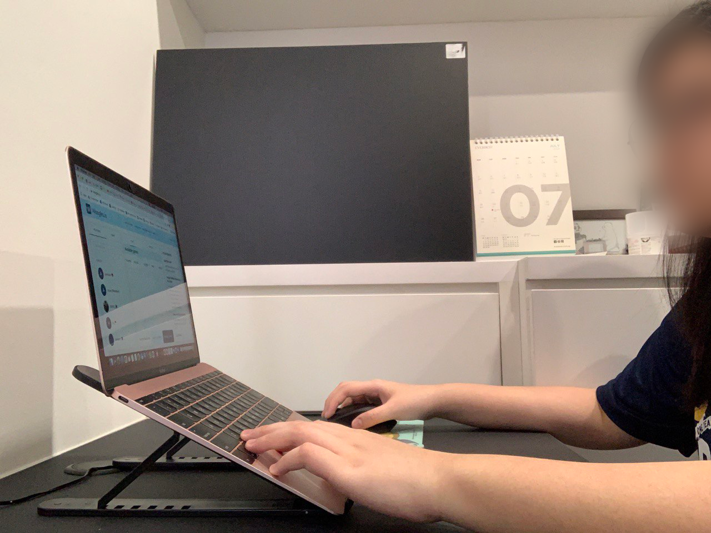

Device 2: Game Device
It is the responsibility of players to ensure that their device is capable of displaying the relevant gameplay features on Woogles and that their internet connection is stable. The recommended view is as shown:
(i) centred/left-aligned board
(ii) visible buttons - ‘Pass’, ‘Challenge’, ‘Exchange’, ‘Play’ along with the ‘Reset Rack’ and ‘Shuffle’ buttons.
(iii) remaining tiles
(iv) player scores

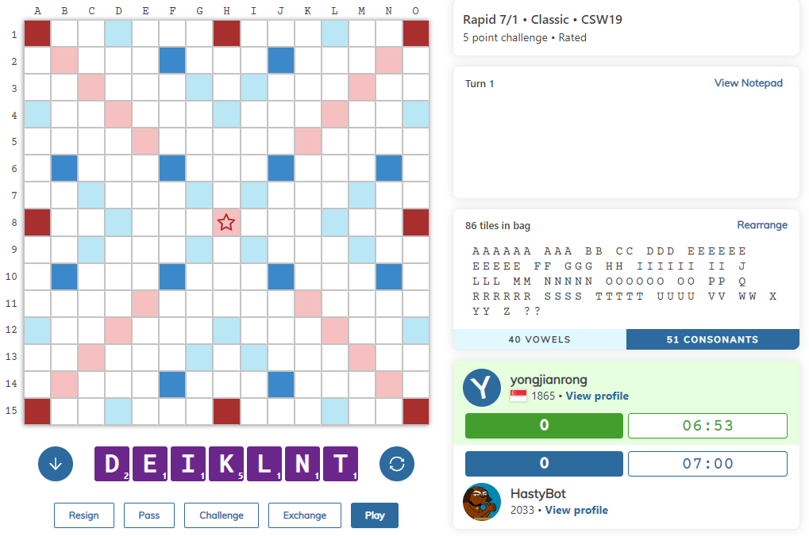

1.5 Written Aids
Note that the following concessions will not be made:
- Use of any aids for calculation
- Use of any aids for word checking/searching

Any violation of these rules will be deemed as cheating.

Part 2 - Starting the Game
2.1 Procedures for Starting a Game Online
To begin a game on Woogles, one player needs to do the following:
1. Click on ‘Match a Friend’.

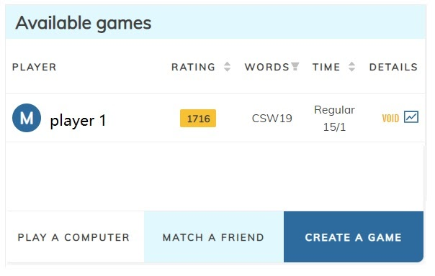

2. In the ‘Friend’ box, type in the name of your opponent.
Check that the following settings match:
CSW 19 (World English), Challenge rule 5-points, 15 minutes, Overtime 1 minute, Unrated.
Once done, click ‘Create game’ and wait for the opponent to accept.
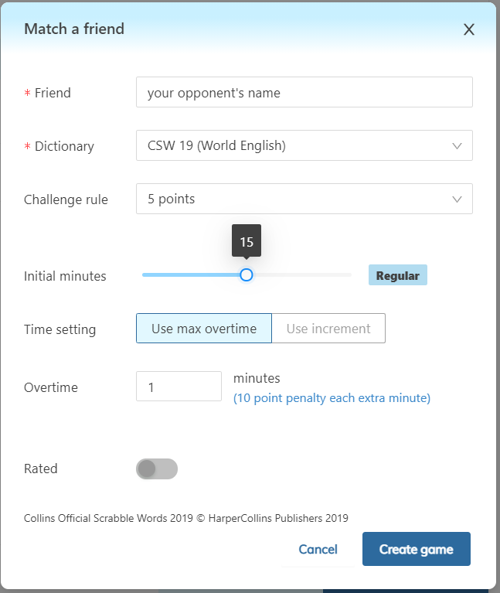
2.2 Determining Who Starts

- The pairing system used by the tournament organisers will determine the player who starts first with an asterisk (*) beside the name.
- Upon accepting a match request from an opponent, Woogles decides the starting player and the timer is immediately started. If the player is not supposed to start, he or she must proceed to pass on the first turn.
- Should the replying player make the first play instead of the starting player, the starting player is allowed to resign the game and start a new game.
- Resignation is not allowed once the first play has been made from both players (excluding the forced pass move to ensure the correct player starts). If either player resigns, the standard procedure for resignation applies.
- Repeated failure to adhere to starts as dictated by the master list or knowingly misrepresenting the start is considered cheating.

2.3 Starting The Timer
The timer is immediately started once either player accepts the match request from an allocated opponent on Woogles.There will be no break or pauses at any point during the game.

Leaving the game room or web page does not pause or end the game in progress, and the timer continues to run down.

2.4 Late Arrivals
In the event of late arrivals, the tournament director will announce to both players the time allocated to each of them. Both players are to acknowledge the message via Zoom before beginning the game. After the game ends, the tournament director will request for the remaining time shown and impose the necessary time penalty.

It is the late player’s duty to keep track of score, accounting for time penalties that resulted from late-coming.

2.5 Shuffling Tiles
Players may make use of the built-in ‘Shuffle’ button () to mix tiles randomly at any point during the game. The mouse can also be used to manually shuffle tiles into their desired positions.

2.6 Special Needs/Disabilities
- Players must notify the Tournament Director, and if relevant, the tournament organisers of any special circumstances, such as physical impediments (e.g. dyscalculia, the inability to count), that may affect their capacity to comply with any procedures set out in these Rules.
This notification should be done at least a week before the tournament.
- At the discretion of the Tournament Director, alternative procedures may be allowed or arranged to assist or accommodate players with special needs.
- At the discretion of the Tournament Director, a player with special needs may be awarded an amount of extra playing time, provided that this extra time will not interfere with the smooth running of the tournament, and with the proviso that the amount of time may be shortened if the tournament is so affected.

Part 3 - The Turn

3.1.1 Making a Move
- To begin entering a move, move the cursor to the desired position.
- Then, click on the square, checking that the arrow’s direction matches the direction of your word.
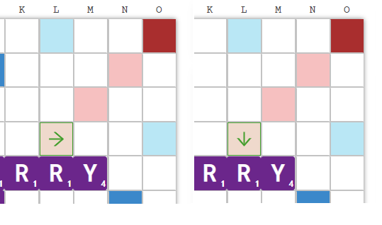
Horizontal (single-click) vs Vertical (double-click) Alignment

- Type the word to be played and press ‘Enter’ on your keyboard or ‘Play’ on screen.

3.2 Exchanging Tiles

3.2.1 Elements of an Exchange
- To complete a turn by exchanging tiles, the bag must contain at least 7 tiles.
- Click the ‘Exchange’ and select the unwanted tiles in the ‘Exchange tiles’ window that pops out.
- Click the ‘Exchange’ button in the ‘Exchange tiles’ window after selecting all the unwanted tiles. Once this button has been pressed, the exchange is final and not reversible..
- If you have tiles that you would like to take back before pressing ‘Exchange’, click the tile(s) again to return them to the rack.

3.2.2 Exchange to Score Zero
An exchange of tiles uses up the turn and scores zero points.
Click on the tiles you would like to change, and these tiles will pop up as shown on the next page. Once done, click ‘Exchange’.
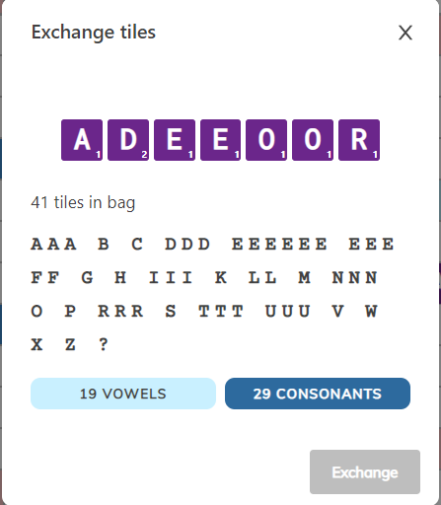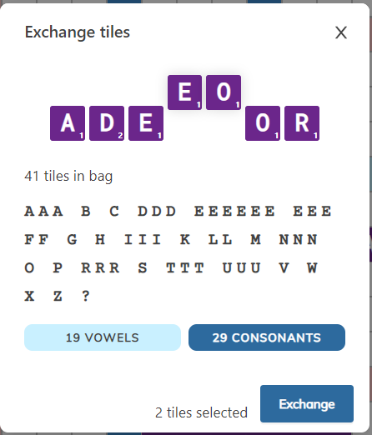
Steps for exchanging tiles: Click/Type the tiles to be exchanged, confirm that the letters pop up (right), then press ‘Exchange’.

3.3 Passing
To complete a turn by passing, a player can click the ‘Pass’ button located below the tile rack and confirm their decision by clicking ‘No’ or ‘Yes’.

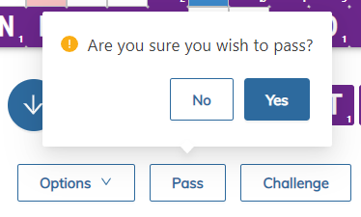

3.4 Significance of Pressing the Timer
To activate the other player’s timer, press ‘Enter’.
If there is no response from the website, click any area on the board and press ‘Enter’ again.

3.5 Keeping Score
Woogles deducts scores automatically for every minute exceeded. Starting at 00:00:00, 10 points will be deducted for every minute exceeded or part thereof.

3.6 Counting the Remaining Tiles
Woogles provides the tile count in two ways, displaying the remaining unseen tiles as well as the number in the bag. Note that the remaining tiles shown on screen are always 7 more than the number of tiles in the bag, due to unknown tiles from the opponent.

3.7 Declaring a Blank
By default, if the rack already contains the letter(s) to be declared as the blank, the letter will be used up first by default.
If the player would like to place them otherwise, the player may use the ‘Shift’ button together with the desired letter to declare a blank.
Example:
With a rack of EINOS?? with ‘?’ representing a blank, the word entered will be SEssION by default, using up the ‘S’ tile before the blanks. The lowercase ‘s’ represents blanks declared as ‘s’. To play the move of sESsion instead, use ‘Shift’+’S’ to declare the first ‘s’ as the blank. Players are to check their blank declaration before committing to the play.

3.8 Drawing Tiles
Woogles automatically draws tiles for a player at the end of each move as long as there are tiles left in the bag. There is no chance of underdrawing or overdrawing during the game.

3.9 Accepting and Challenging Turns
To accept a turn, continue the game as per normal.

To challenge, the player should press the ‘Challenge’ button anytime before a new move/exchange is made by himself.

3.10 Procedures for Issuing and Adjudicating a Challenge

Part 4 - Interrupting the Game

4.1 Neutralising the Timer
There is no way to neutralise or pause the timer in the middle of a game. If an emergency arises, refer to Section 4.5.

Note that leaving the webpage does not stop the timer.

4.2 Leaving the Area
Players are not to leave the playing area at any point in time during a game, except in the event of an emergency (refer to Section 4.5). A player is deemed to have left the playing area if their face and/or hands are not visible on the Zoom camera. Leaving the playing area may be constituted as cheating. All incidents of players leaving the area should be reported to the Tournament Director, who will investigate and take the necessary action at his discretion.

4.3 Scope of Uninvited Intervention by the Director in a Game
Throughout the course of the game, if the director suspects that there has been foul play or any violation of the rules mentioned, the director reserves the right to pause or terminate the game depending on the severity.

4.4 Scope of Intervention by a Third Party in a Game
- A third party may not intervene DIRECTLY in an observed game in any way, including in errors of procedure and cheating noticed by the third party;
- Instances of cheating noticed by a third party must be reported to the Tournament Director, who must then investigate the allegation/s and take action as necessary, using discretion;
- Errors of procedure noticed by a third party should be reported to the Tournament Director.

4.5 Emergencies and Medical/Health Problems
In the event of an emergency (whether medical or not), the affected player’s timer CANNOT be stopped due to the design of Woogles and the Tournament Director must be called. The Tournament Director must quickly assess the emergency, decide on a course of action (including noting down the time remaining on the affected player’s clock) and, in order to preserve the smooth running of the tournament, immediately the affected player’s timer. If the affected player feels sufficiently recovered within the game time left for that player then the player may attempt to finish the game, otherwise the affected player resigns the game due to the emergency. (see 5.7 Resigning)

Part 5 - Ending the Game

5.1 ‘Playing Out’

5.1.1 Procedure for ‘Playing Out’
‘Playing out’ occurs when, after completing a turn, a player has no tiles remaining and no tiles remain to be drawn from the bag.

5.1.2 Actions to be Taken Upon ‘Playing Out’
A player attempting to play out will press ‘Enter’ as usual.

The opponent must then either:
- Accept the turn by pressing ‘Pass’; or
- Challenge the turn by pressing ‘Challenge’

The opponent’s time will continue to run until one of these buttons has been pressed.

Quick Tip:
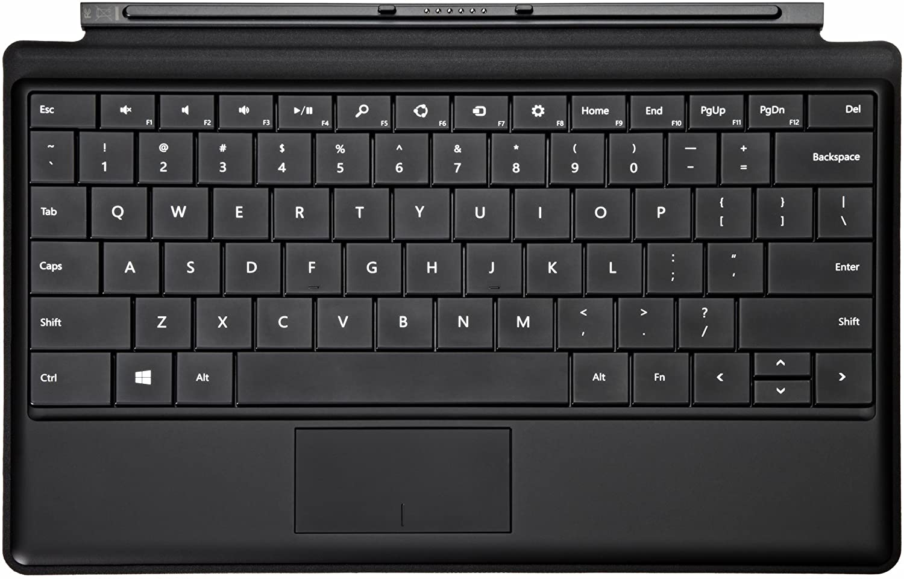
The shortcut key for ‘Pass’ is the ‘2 / @’ key on the keyboard.
The shortcut key for ‘Challenge’ is the ‘3 / #’ key on the keyboard.
Tap the same key a second time to confirm the decision to Pass / Challenge.
5.1.3 Tiles Remaining
- When one player has played out, then his or her score is increased by twice the value of the opponent’s unplayed tiles, and the opponent’s score is unchanged.
- If neither player is able to play out then refer to 5.2 (Six Consecutive Zero Scores End the Game) just below.

5.2 Six Consecutive Zero Scores End the Game
The game ends after six consecutive turns scoring zero, resulting from any combination of passes, exchanges and successful challenges. If this occurs, each player’s final score is reduced by the total value of the tiles on his or her rack.

5.3 Time Penalties

5.3.1 Ascertaining When Time Penalties Apply
A player who exceeds his or her assigned game time incurs time penalties. This occurs once the player’s score and time turns red. Timing is measured to the nearest millisecond on Woogles, although it is displayed to 1 decimal place.
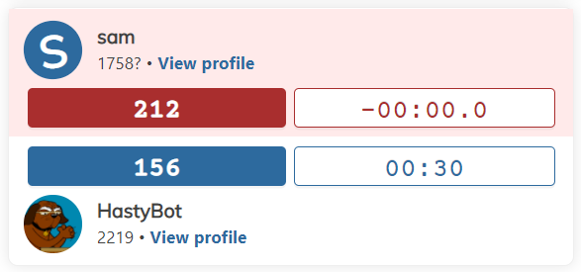

5.3.2 Application of Time Penalties
A player’s score is reduced by 10 points per minute or part thereof by which he or she exceeded the assigned game time.

5.3.3 Overtime Leading to Forfeiture
A player who goes over the assigned game time by 1 minute immediately loses the game (a forfeit loss). This is regardless of the score of the player who went overtime beyond 1 minute.

For the winner arising from the forfeiture, two scenarios may occur:
- Final score remains unchanged if he/she was already leading.
- If the winner was trailing initially, +10 spread will be assigned to him/her.

5.3.4 Standard Game Time
An assigned game time of 15 minutes for each player is considered standard.

5.4 Result Slip
5.4.1 Result Slips Final Once Submitted
Both players are required to submit the results slip at the end of the game. If the results submitted are consistent, the results are considered final. This binds the players and the Tournament Director, unless:

- After submitting the results, one or both players petition the Director to correct ONLY an error where the final game scores of the winner and loser were accidentally reversed. The Tournament Director must make every reasonable effort to correct this error but may refuse if doing so will affect the draw or smooth running of the tournament in a way the s/he deems to be unacceptable or overly complicated. The Tournament Director must ensure that both players are made aware of the amendment to the result slip.

It is the players’ responsibility to submit the correct results and to check the standings to ensure that individual records are correct. The Tournament Director’s decision on all disputes and/or appeals will be final.

5.5 Resigning

- A player may not resign a game except in an emergency.
- A resigned game is forfeited and cannot be resumed.
- The game margin in a properly resigned game is the greater of the following:
(i) 50 points;
(ii) the non-resigning player’s lead at the time of resignation plus 50 points.

If the Tournament Director has reason to believe that the resignation function is being abused, he will determine an appropriate margin for an improperly resigned game. Repeated resignations due to non-emergency reasons may lead to expulsion from the tournament.

Part 6 - Conduct
6.1 General Conduct
All players are expected to observe decorum and abide by fair play throughout the entire tournament. The Tournament Director reserves the right to issue penalties to players as he deems fit for any offences committed during the course of the tournament.

6.2 Offences
The integrity of the tournament is of utmost importance. Any attempts to cheat or undermine the integrity of the tournament in any way will be dealt with severely. The Woogles platform includes a built-in cheating detection software that will be used during the tournament. Players will also be monitored through their Zoom camera to ensure fairness to all players.

Abusive behaviour towards other players or tournament officials will not be condoned. Players are encouraged to report such cases to the tournament officials and recalcitrant players may be asked to leave the tournament.

6.3 Right of Appeal
Players may raise an appeal to the tournament officials if they feel that an issue has been unfairly dealt with. The appeal will be reviewed and the decision made by the tournament officials will be final.

